Direct Deposit Authorization Form
Please print and complete ALL the information below.

Name: ____________________________________________________________

Address: ____________________________________________________________

____________________________________________________________

Email Address: ____________________________________________________________

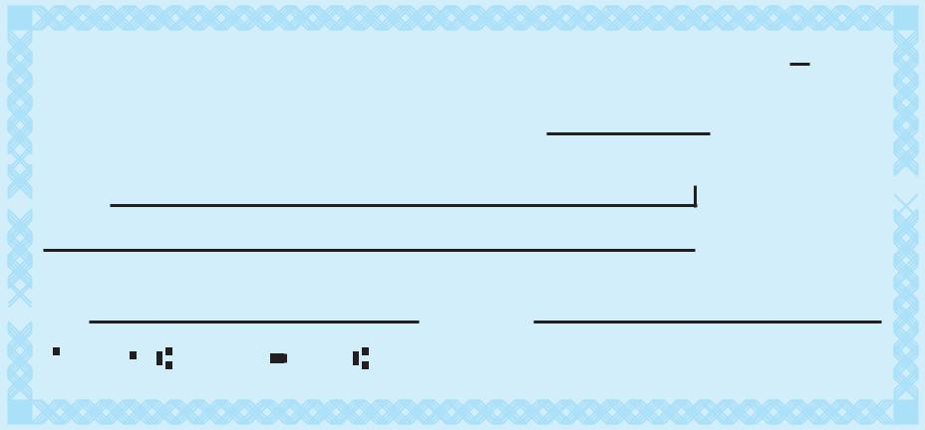
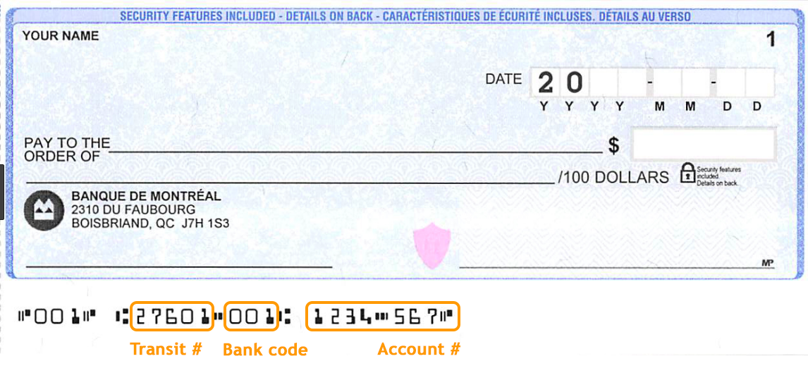

Name of Bank: ____________________________________________________________

Account #: ____________________________________________________________

Type of Account: Checking Savings (Circle One)

Please attach a voided check for each bank account to which funds should be deposited.

[Huu- ay- aht First Nations] is hereby authorized to directly deposit my funds to the account listed above. This authorization will remain in effect until I modify or cancel it in writing.

This form is to be completed by you with your personal banking information only. We cannot deposit other people's distribution into your bank account unless a Power of Attorney document is provided to us.

By checking this box, I agree that all the information provided on this form is accurate and is my personal banking information.

Signature: ____________________________________________________________

Date: ____________________________________________________________

